**H.S. Prannoy rises to career-best World No: 12 in Badminton Rankings**

Jun 18, 2015 15:45 IST

[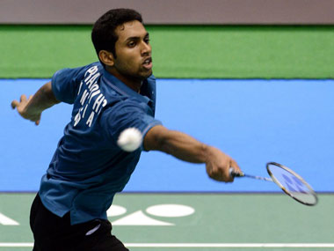](http://s1.firstpost.in/wp-content/uploads/2015/03/Prannoy-AFP.jpg)

**Indian shuttler HS Prannoy rose a place to be at No.12 in the Men's Singles Rankings released by the Badminton World Federation (BWF) on Thursday. This is the 22-year-old Kerala shuttler's career-best ranking.**

Meanwhile, Kidambi Srikanth remained the top ranked Indian shuttler at No.3 while reigning Commonwealth Games Champion Parupalli Kashyap is at No.10.

In Women's Singles, Saina Nehwal stayed at No.2 while P.V. Sindhu is placed at No.14.

Women's Doubles pair of Jwala Gutta and Ashwini Ponnappa are at No.15.

-----------------------------------------